

# Automatic Water Level Indicator in the Crop Field Using Arduino

**Group # B Sec- M**

|  |  |  |
| --- | --- | --- |
| **Group Members** | | |
| **Name** | **ID** |
| **Ananya Chowdhury** | **18-39028-3** |
| **Durjoy Dey** | **18-39013-3** |
| **Joy Karmokar** | **18-39263-3** |
| **Sazid Al Farabi** | **19-39478-1** |
| **Tonima Hossain Pia** | **18-38892-3** |
| **Salma Jahan Sahara** | **18-38788-3** |
| **Sharika Parvin Joba** | **18-38721-3** |
| **Nurul Huda Bhuiyan** | **18-38983-3** |

**Name of the Course Teacher**

**Dr. Ferdous Jahan Shaun**

**Assistant Professor**

**Fall Semester 2021-2022,**

**December, 2021**



**Abstract— Water is a very important factor in agricultural production and is a key of our quality of life as well. Monitoring water level of a water source, such as dams, water tank or bore-well plays a key role in agricultural management and development. This work aimed at development of an automatic water level indicator. Developing a water level indicator can be helpful to reduce the water wastage. The major components used for the development of the water level indicator were Arduino board, sonar sensor, buzzer, LED lights. The automatic water level monitoring system was realized using a sonar sensor attached to an Arduino Uno to process the analog signal coming from the sensor into a useable digital value of distance also we added a buzzer in this system so that we can be aware about the increasing level of water.**

**Index Terms— automation, development, monitoring-system, water-level, sonar sensor.**

**I. INTRODUCTION**

The project is Arduino based automatic water level controller and indicator. Here, we are going to measure the water level by using help of sonar sensors. We did this some researches to make this “Automatic water level indicator”. By analyzing many resources, we find out what we need to use to build this. For developing the project, we got help through the internet.

Our country is an agricultural country so this project will be helpful for our agricultural works to maintain the water level of our crop fields. There are many projects. similar to this topic which motivated us to work on water level indicator. Also, we got the motivation by watching many real-life projects as well as we thought this project will be easy for us to make and also the water wastage problem in our country motivated us. Moreover, the changing weather or season which create a great impact in our crop field. It says that every crop requires different amount of water in different seasons and this can be done by using automatic water level controller which will also help in reducing wastage of water. This “Arduino based automatic water level indicator” will help us to protect our farmers crop field from dryness and also from the excess water level which will aid to make our crops healthy as well.

The system is basically designed to prevent the excessive amount of water in crop field. With the help of this technology water level can be controlled. A water pump will be there for the water source, a water exhaust motor and sensor to monitor the level of water in the crop field. Minimum level of water can be sensed by using a sensor and using a monitor water level can be observed. The monitor will notify whether the water level has increased or decreased. A buzzer will give alarm if the water level goes up. By using a generator extra amount of water can be reduced and can be provided if water level goes down.

This project is structured as follows. In Section II we discussed the literature review to create a water level indicator. The methodology and modeling in Section III, results and discussion in Section IV and conclusion in Section V. References that we used to create this project and writing the report in Section VI.

**II. LITERATURE REVIEW**

In this paper, we use soil moisture sensor is used which is placed in the soil and water level sensor is used which is placed in the reservoir. The sensor sends the information to the microcontroller. An algorithm was designed which converts the analogue data of the sensor to percentage. This paper designed an automatic irrigation system controlled by a microcontroller ATMEGA328. The moisture sensor and the water level sensor send information to the microcontroller. When the moisture of the soil reduces below the set parameter the microcontroller automatically turns on the motor. The current soil condition is displayed in the LCD and any change in the state of the system is notified via the LED's, buzzer and the LCD display.

Sandeep Kaur et al., [1] proposed an Automatic Irrigation System (AIS) for different crops with Wireless Sensor, Network (WSN) deploying sensor nodes in the agricultural field. Sensor nodes sense the soil temperature, sunlight, pH, relative humidity and groundwater parameters and different types of soil and crops at one time. Then sensor nodes send the sensed data to base station, where the data can be analyzed and meaningful data stored in the database and this data help the AIS in decision like: whether a crop requires water or not and the amount of water required by the plant. Although, the proposed AIS will reduce the wastage of water and save crop from unconditional seasons like rainfall condition and over irrigated and less irrigated conditions, but the drawbacks are numerous like if the base station is compromised, the entire system fails and sensor nodes are expensive.

N. Siththtikumar et al., [2] prototyped a low-cost automated water irrigation system for home gardens using Arduino Uno, LCD, moisture sensors, solenoid valve, flow sensor and pipe lines. Moisture sensor array embedded in garden will sense the water level continuously, when water level goes low, the solenoid valve attached to the pipe line system will automatically open allowing water to flow to the garden via pipe line network. On the other hand, if the water level is sufficient enough the solenoid valve automatically closes restricting water flow to the garden. The LCD display will show the amount of water used in liters by sensing the water flow by the flow sensor also it shows the flow rate and temperature in the garden. The system is low cost and efficient for small garden but it needs improvement in other to act base on the soil type.

Syed Musthak Ahmed et al., [3] proposes to make the farmers stay away from the field for the whole day, prototype that senses soil moisture and based on the data, the designed system instinctively turns ON the water pump to the field. As the soil reaches an optimum moisture level, then the water pump automatically gets turned OFF. It is shortly can termed as maintenance free agriculture where farmers can be prevented from breathing harmful chemicals by staying on the field for the whole day and also estimates the ambient temperature and humidity in the field and senses the daylight and rainfall intensity on the agricultural field.

Divani et al., [4] elucidates that the major problem facing in modern society is the water resource shortage; agriculture is one of the demanding jobs which consumes large quantity of water. So, we must utilize maximum water in an efficient way. The components are moisture sensor; motor/pump and Arduino board are programmed using software. The predetermined range of soil moisture and temperature is set according to plant requirement. If soil moisture value is less than threshold system automatically triggers water pump on till sensor meets threshold and then sets off automatically. The value is passed on to the user network through an application.

Kotni et al., [5] elucidates that the water content in the soil controls the action done by the Arduino. The soil moisture sensor will detect the water content in the soil and feed it to the data pin of the sensor and send the data to Arduino for further processing. The code used in this project focuses on the threshold moisture of the soil. If the data (moisture content) collected by sensor is greater than the threshold moisture required for the respective soil, then the Arduino gives blank feed to the motor enabling it to give blank output or none output. When the data (moisture content) is less than the threshold moisture required by the soil, the Arduino feeds the motor to pump the water from the sprinklers to the soil.

**III. METHODOLOGY AND MODELING**

**3.1. Introduction**

The Arduino Uno is utilized in this project. Many projects have been reported that employ the Arduino microcontroller, such as robots and mini-projects. The system is basically designed to prevent the excessive amount of water in crop field. With the help of this technology water level can be controlled. A water pump will be there for the water source, a water exhaust motor and sensor to monitor the level of water in the crop field.

**3.2. Working principle of the proposed project**

**3.2.1. Process of Work**

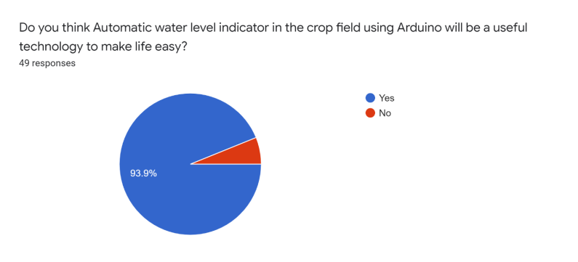

**If we see the above pie chart it can be seen that 93.9% people agreed Automatic water level indicator using Arduino will make life easier.**

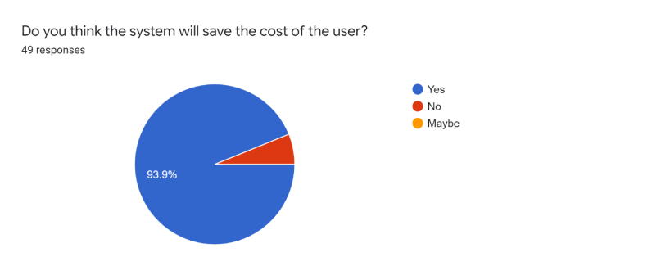

**Cost friendly is really important and 93.9% of the people think this system will save the cost of the user.**

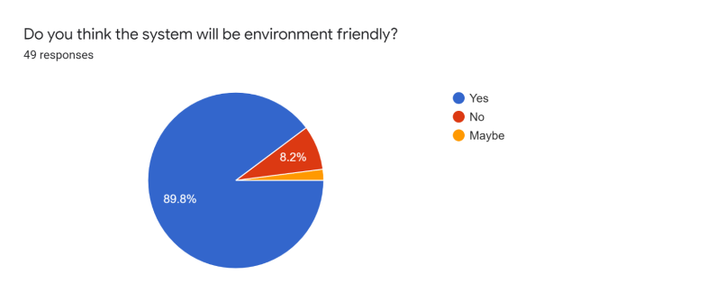

**The system needs to be environment friendly and most of the people agreed to this statement as well which encouraged us to proceed to create a system like this using Arduino**

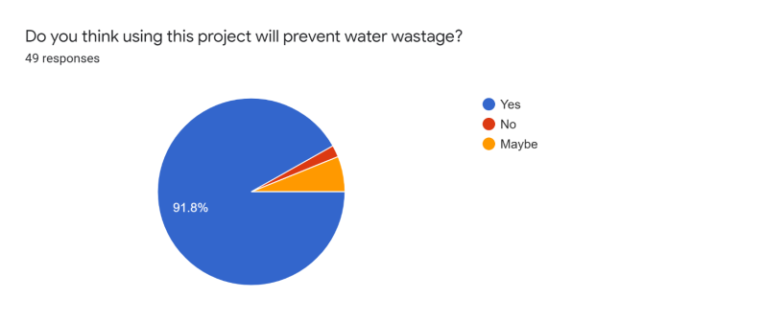

**Saving water is very important for our country. 91.8% people agreed that this system might save the water and thus we moved further to do this project.**

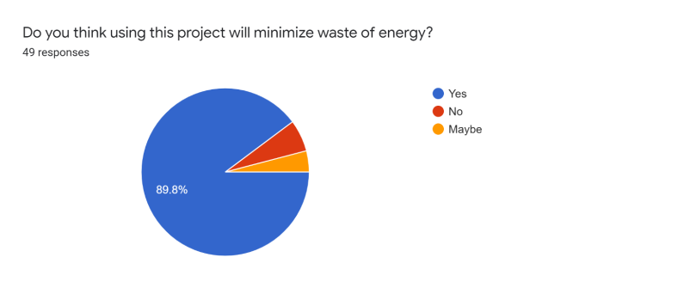

**This project will definitely minimize the waste of energy and many people supported to this statement as well.**

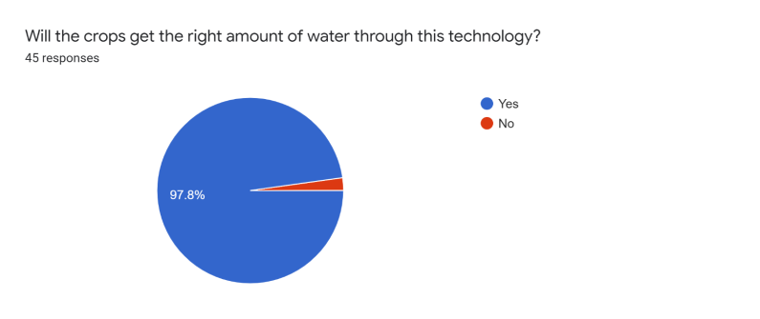

**The main purpose of the project is to maintain the water level of crops so that they get the right amount of water and does not get damaged due to excess water.**

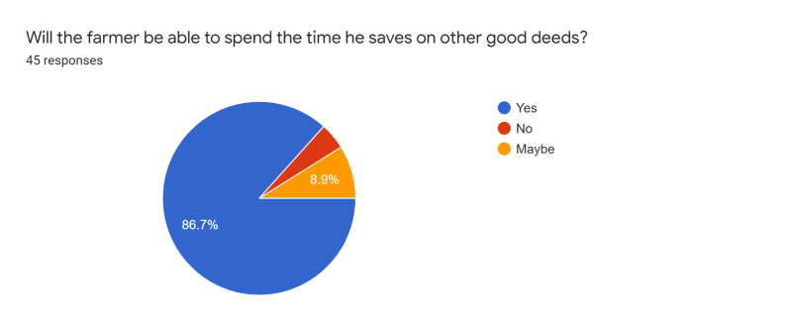

**Time saving is one of the main advantages of this system as the system is automated and here, we can see 86.7% of the people thought the same from this system.**

**3.3. Description of the important component**

**a)** Arduino UNO: is an opensource microcontroller board based on the Microchip ATmega328P microcontroller and developed by Arduino.cc. The board is equipped with sets of digital and analog input/output (I/O) pins that may be interfaced with various expansion boards (shields) and other circuits. The board has 14 digital I/O pins (six capable of PWM output), 6 analog I/O pins, and is programmable with the Arduino IDE (Integrated Development Environment), via a type B USB cable. It can be powered by the USB cable or by an external 9-volt battery, though it accepts voltages between 7 and 20 volts. It is similar to the Arduino Nano and Leonardo. The hardware reference design is distributed under a Creative Commons Attribution-Share-Alike 2.5 license and is available on the Arduino website. Layout and production files for some versions of the hardware are also available.

**b)** Grove Ultrasonic Ranger: is a non-contact distance measurement module which works at 40KHz. When we provide a pulse trigger signal with more than 10uS through signal pin, the Grove Ultrasonic Ranger will issue 8 cycles of 40kHz cycle level and detect the echo. The pulse width of the echo signal is proportional to the measured distance.

**c)** LED Light: A light-emitting diode (LED) is a semiconductor light source that emits light when current flows through it. Electrons in the semiconductor recombine with electron holes, releasing energy in the form of photons. The color of the light (corresponding to the energy of the photons) is determined by the energy required for electrons to cross the bandgap of the semiconductor. White light is obtained by using multiple semiconductors or a layer of light-emitting phosphor on the semiconductor device.

**d)** Buzzer: is used for given some indication and normally this indication is kind of a warning. Proteus has a built-in component for buzzer and it’s an animated component means it gives a sound (beep) when it’s turned ON.

**e)** Motor Shield: is a driver module for motors that allows you to use Arduino to control the working speed and direction of the motor. Based on the Dual Full-Bridge Drive Chip L298, it is able to drive two DC motors or a step motor.

**f)** OLED Display: shows the messages which is written in the flowchart as per as conditions.

**3.4. Implementation**

The system was created in order to maintain the water level of crops so that excess water does not harm the crops. The water level is ideal when the level is from 41cm to 50cm. The water level is considered as less when it is below 40cm and high when the level is above 50cm. When the ultrasonic ranger identifies the water, level is below 40cm, M1 starts at a forward direction at speed 255, LED1 turn on (green), OLED display shows “Supply pump is started and its supplying water to the Crop Field”. When the ranger finds the water, range is between 40cm to 50cm the motors stay at ideal state and LED3 turns on (Yellow) and the display shows “Water level is at ideal situation for the Field” and both the motors are turned off automatically. When the ranger finds water, level is above 50cm, Buzzer starts, LED2(Red) turn on and M1 stops and M2 starts to rotate at a forward speed of 255 in order to pump out the excess water, display shows the message as “Exceeding pump is started and it’s decreasing the water level.”

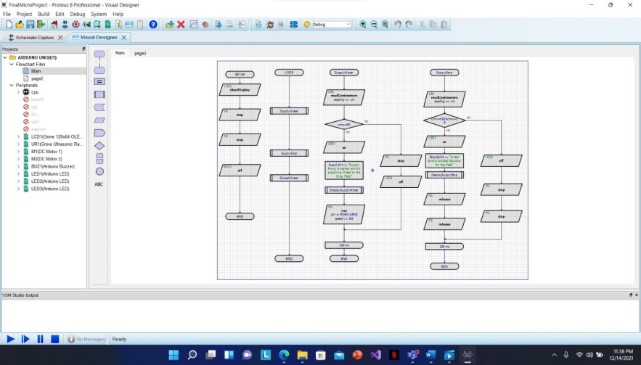

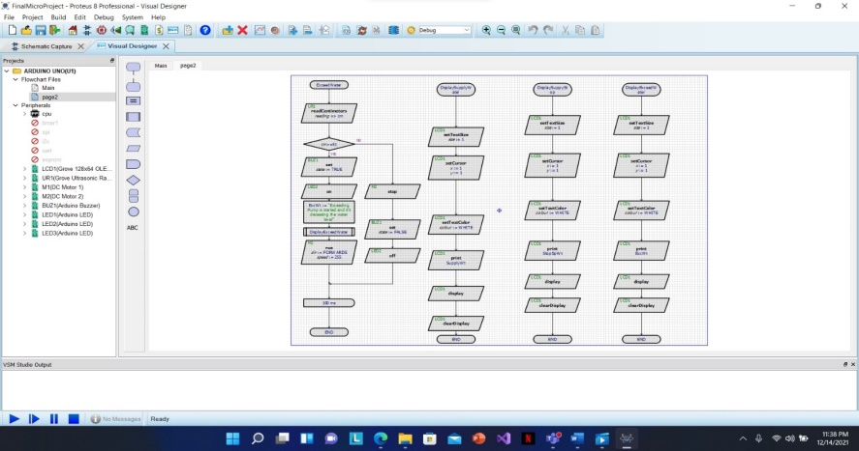

**3.5. Test/Experimental setup**

The primary design we used is from the block diagram. Initially we planned that Ardu ino Uno was programmed to control exhaust pump, alarm, supply pump and supply pump motor. The sensor was used to control Arduino Uno. Finally, we implemented the rough design in Proteus.

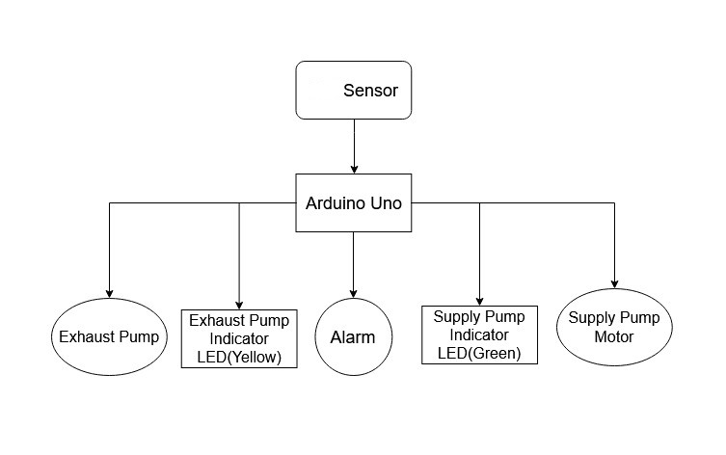

The challenge we faced was: at first, we thought to use Soil sensor but unfortunately, we did not get the required output so we used Grove Ultrasonic Ranger.

The circuit shows how an automated water level indicator is designed and controlled using Arduino. The project is based on a microcontroller board design created by a number of suppliers utilizing a variety of microcontrollers. These systems come with a number of digital and analog input/output (I/O) pins that can be used to connect to expansion boards and other circuits. Arduino 328 was utilized in this project to program on what to do when a specified water level has reached and how to control the motors according to the water level. To begin, we create a schematic diagram

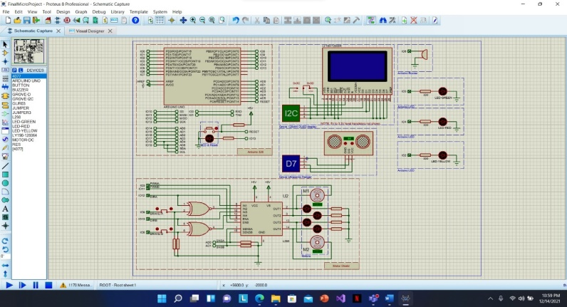

(As shown in Fig..) that will allow motors to run at various speeds. The motor's speed would be regulated by the Grove Ultrasonic Ranger, which will be achieved by adjusting the ranger’s level, resulting all the motors to pump or exhaust water on at a specific speed. M1 motor is used to pump water into the fields and M2 is used to pump out the excess water. Arduino buzzer was used to alert if the water level rose higher than 50cm. In order to indicate different levels of water in the field 3 (Green, Yellow, Red) Arduino LED was used. LCD1 (Grove 128x64 OLED display) was used to show message when water is supplied, stopped & exceeded.

The challenge we faced was: at first, we thought to use Soil sensor but unfortunately, we did not get the required output so we used Grove Ultrasonic Ranger

**3.6. Cost analysis**

Each component has a different price. First and foremost, we must choose those that are significantly less expensive and hence more widely available. It must be conducted very successfully, despite the fact that it is less expensive; otherwise, it will fail. As a consequence, all of the chosen components fulfill our standards, and we can confidently state that it is both affordable and effective. The Arduino UNO R3 board cost 640 taka only.

Grove 128x64 OLED display cost 550 taka. Dual channel motor shields cost 1,399 takas. Dc water pump motors cost 450*2 = 900 taka. Grove Ultrasonic Ranger cost 2,049 taka. Arduino buzzer cost 45 taka. We may simply implement this experiment within 6,583 BDT. We considered utilizing a Raspberry Pie Board for this project at first. However, it came at a cost of BDT 11,943 taka.

**IV. RESULTS AND DISCUSSION**

For this experiment we have used proteus software to build our project. In this software we have used Arduino Uno 328, Grove 128*64 OLED display, Grove Ultrasonic Ranger, Arduino Motor Shield(R3) with DC Motor, Arduino Buzzer, Arduino LED (green), Arduino LED (red) and Arduino LED (yellow).

|  |
| --- |
|  |
| Figure Schematic Capture of water level indicator in crop field |

We have taken all these components from the peripheral which we can find in the flowchart Visual Designer section. From the Breakout Peripherals Category in Add peripheral section we have taken Arduino Buzzer, Arduino Led (Green), Arduino Led (Red), Arduino Led (Yellow). From the Grove Category we have taken Grove Ultrasonic Ranger Module, Grove 128x64 OLED display Module. Also, from the Motor Control Category we have taken Arduino Motor Shield(R3) with DC Motors.

|  |
| --- |
|  |
| Figure Flowchart of the Simulation |
| |  | | --- | |  | | Figure Flowchart of simulation page2 | |
|  |
| Here Figure 2 and 3 are the flowchart of the simulation. |
| There are 3 different modes in the water level indicator in the crop field. The simulation of some of the modes of this projects are given below.  Here in Figure 4, the M1 motor is running forward and M2 motor is stopped in that condition which defines that if the water level is less or equal 40 cm then the motor (Forward) will supply water and the Green Led light will be on.   |  | | --- | |  | | Figure Water Supply Motor and Green Led is on. | |
| Here in Figure 5, The water level is in ideal state and both of the motors are stopped. The water level of the ideal state is between 41 to 50 cm and led yellow light will be on.   |  | | --- | |  | | Figure Both Motors are stopped and Yellow light is on. | |

Here in Figure 6, the water level is higher than ideal and M2 motor (Forward) will be on and it will exhaust the extra water. When the water level is higher or equal to 51 cm, it will be activated and the Buzzer will be on to alert about the situation and Red led light will be on.

|  |
| --- |
|  |
| Figure Exhaust motor, Arduino Buzzer and Red Led is on |
| **V. CONCLUSION**  In this experiment, the goal was to create a water level indicator for crop field. The speed of the motor was controlled by using a sonar sensor. The display was also used to monitor the different water level. We are using Arduino and the Proteus software in this project. After creating flowchart and build the project the simulation run successfully. With different percentage of dummy accelerometer value or potentiometer value, we had attained different results successfully. Therefore, the aim of this project was fulfilled. Due to time limitations, we couldn’t able to add more features like buzzer which will give us alarm when the water level goes down and Xbee transmitter and receiver, which is a shield that allows Arduino to communicate wirelessly with the use of zigbee. This is basically, a prototype project that means when the industries will make it, they can make it at a minimal price. The main purpose of this project is to reduce the wastage of water and make a low-cost water level indicator system.  **References**   1. Sandeep Kaur and Deepali, (2017) "An automatic irrigation system for different crops with WSN", 2017 6th International Conference on Reliability, Infocom Technologies and Optimization (Trends and Future Directions) (ICRITO), Amity University Uttar Pradesh, Noida, India 2. N. Siththtikumar and M. W. P. Maduranga, "Designing and Implementing an Arduino Based Low-Cost Automated Water Irrigation System for Home Gardens", International Research Symposium on Engineering Advancements 2016 (IRSEA 2016) 3. Ahmed, S. M., Kovela, B., & Gunjan, V. K. (2020). IoT Based Automatic Plant Watering System Through Soil Moisture Sensing—A Technique to Support Farmers’ Cultivation in Rural India. In Advances in Cybernetics, Cognition, and Machine Learning for Communication Technologies (pp. 259-268). Springer, Singapore. 4. Divani, D., Patil, P., & Punjabi, S. K. (2016, April). Automated plant Watering system. In 2016 International Conference on Computation of Power, Energy Information and Communication (ICCPEIC) (pp. 180-182). IEEE. 5. Siva, K. N., Bagubali, A., & Krishnan, K. V. (2019, March). Smart watering of plants. In 2019 International Conference on Vision Towards Emerging Trends in Communication and Networking (ViTECoN) (pp. 1-4). IEEE. |